schools to watch
cascade middle school—visitor’s guide

Cascade Middle School

2020-2021School Statistics

Community: Rural
Enrollment: 399
Grade Levels: 6-8
School Schedule: Traditional

Student Demographics
1.5% Hispanic
94.7% White
0.5% African American
1.3% Multi-Racial
0.3% Native American
1.8% Asian
0.0% Pacific Islander
33.8% Free/Reduced Lunch
1.0% English Learners
20.6% Students With Disabilities

 | 2016 ISTEP+ | 2017 ISTEP+ | 2018 ISTEP+ | 2019 ILEARN
Math | 58.4% | 63.7% | 63.1% | 56.1%
ELA | 78.4% | 78.1% | 76.5% | 64.5%
Science | 73% | 78.9% | 64.8% | 73.5%
SS | 90.7% | 88.2% | 89.1%

Student Attendance – 96.1%
CMS ranks in the top 7% of all middle schools in the state on ILEARN performance.

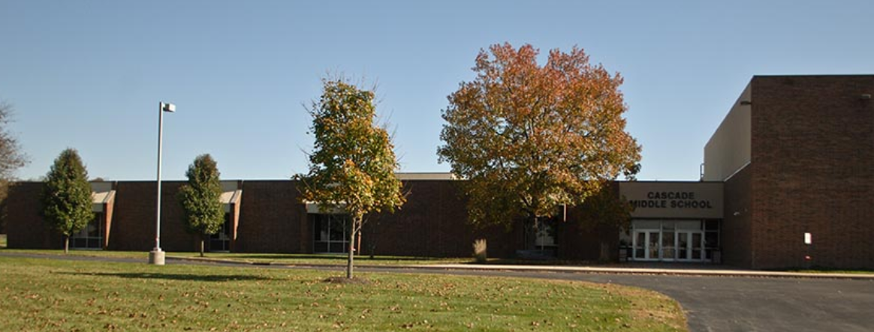
Designated in 2020

Cascade Middle School ● Mill Creek Community School Corporation ● Hendricks County ● www.mccsc.k12.in.us ● Principal Kale Blickenstaff kblickenstaff@mccsc.k12.in.us ● 6423 S CR 200 W, Clayton, IN 46118 ● Phone (317) 539-9285 - Fax (844) 303-1907

School Characteristics and Replicable Practices

Academic Excellence
- Teachers use a variety of formative and summative assessments (PIVOT, ExactPath, IXL, STAR Reading, etc.).
- Students earn the opportunity to participate in various high school credit courses (Algebra, Geometry, PACE, Life Science, French, Spanish, Physical Education, Advanced Art).
- Based on multiple data points, there are two levels of interventions available in math, reading, and a resource for students to get help with school work and organizational skills.
- Teachers collaborate on cross-curricular grade level lessons to give students more “real world” experiences.
- CMS offers a variety of courses with real-world applications (Preparing for College and Careers, AV Tech, STEM, Sales and Marketing, Computer Science, Personal Finance, Exploring Agriculture, etc.).
- CMS has implemented a mentor period to support the academic, behavioral, and social-emotional needs of our students.

(Continued)
Schools to Watch Page 2
Cascade Middle School

- CMS has expanded elective offerings at the 6th-7th grade level to allow students to pursue their interests. These courses include Sales and Marketing, CMS Student News, STEM, Creative Connections, Teen Novels, Computer Science, Global Citizenship, Health and Wellness, and Money and Me.
- Teachers use a combination of strategies such as simulations, project-based learning and hands-on learning to help reinforce student mastery of the concepts.
- Advanced art students create murals around the school as their final year project - giving students a sense of ownership in our building.
- The schedule provides students with sufficient time to meet rigorous academic standards.
- Study halls are also available for those taking multiple high school credit classes.
- The Learning Hub offers extended hours for WiFi access and staff assistance as well as a “homework help center” where peer tutors can provide support.
- Teachers use weekly department/team meetings to evaluate benchmark data and determine which students might be in need of additional support.
- Supplemental courses are available through Edmentum (PLATO and Exact Path) for students whose needs can’t be met in the time and format of a traditional classroom.
- Behavior specialists are on site to help meet the needs of students who struggle behaviorally.
- Teachers participate in weekly meetings as a whole staff, in departments, on school-improvement committees, and in their grade level teams.
- MCCSC offers three district-wide professional development sessions per year with the involvement of all four schools.

Developmental Responsiveness
- All CMS students participate in a daily 15-minute “Mentor Period” where teachers emphasize SEL skills and intentionally work to build relationships with students.
- 4 core values are building relationships, engaging instruction, high expectations, and respect for all.
- Teachers have been provided with training and professional development regarding trauma-informed discipline, adverse childhood experiences (ACEs), suicide prevention, social media safety, among other pertinent areas.
- In addition to the partnership with Essential ABA (behavior specialists), CMS partners with multiple outside agencies for additional counseling, therapy, and emotional support, such as The Hamilton Center and Care to Change.
- CMS is in the sixth year of a 1:1 digital instruction initiative using Chromebooks.
- Teachers utilize discussions via the learning management software known as Canvas, facilitate Socratic seminars, link ideas via concept mapping using Mindmup, embrace cooperative learning strategies with the collaborative tools of Google, and use think-pair-share discussions both virtually and live with classmates.
- Teachers document classroom rules and display them in multiple locations for students and parents to access.
- A PBIS system supports and encourages positive behaviors.
- The Cascade Middle School instructional strategy committee facilitates a cross-curricular project to bridge the gaps between areas of study.
- Cascade Middle School offers a wide variety of high ability courses, high school credit courses, and other elective courses that aren’t typically offered at the middle school level.
(Continued)
Schools to Watch Page 3
Cascade Middle School

- Extracurricular clubs revolve around robotics, coding, board games, reading, art, leadership development, and television broadcasting.
- Students perform a yearly musical that sells out our auditorium and performs in many band concerts as well.
- 8th grade students the opportunity to meet with high school staff early in the year to discuss expectations, graduation requirements, and opportunities available through CHS.
- 8th graders visit Area 31 to explore vocational programming that will be available to them as high school students.
- Students serve as Ambassadors for Riley Children’s Hospital.
- Parents are informed through our weekly newsletter, which includes a written description from each class as to what objectives are being covered in each area, as well as any important information from the staff, and our web programs Canvas and PowerSchool.
- The community is informed through social media sites such as Facebook and Twitter as well.
- Community events include grade-level nights, a Back to School Bash, parent nights, and family swim-and-movie nights.
- Students are encouraged to participate in multiple community service projects, and community outreach programs through the FFA.
- Students are encouraged to participate in many other community service projects through National Junior Honor Society, as well as grade level service projects.
- Student council sponsors our school’s Pennies for Patients, Toys for Tots, and Ethiopian child sponsorship campaigns.

Social Equity
- “Cascade Cash” helps to combat and alleviate negative behaviors by reinforcing positive actions that are seen among students, including helping a peer in need, showing kindness and respect to teachers, staff members, and fellow students, actively making good decisions, and much more.
- CMS offers a variety of inclusion classes in which students may get needed help from instructional aides on a daily basis.
- Resource teachers go into Math and Language Arts classes to assist special needs students with their tasks and assignments.
- A homework help center in the Learning Hub is equipped with peer tutors to help assist students with homework and preparing for tests and quizzes.
- At the eighth grade level, students have the ability, based on academic standing, to participate in a class called PACE, which is a fully integrated social studies and language arts class taught by the eighth grade U.S. History teacher and the eighth grade Language Arts teacher.
- The entire staff integrates reading and writing into their set curriculum, allowing the students to be exposed to and interact with a variety of texts.
- Staff integrate the multiple intelligences into their lessons.
- Teachers offer a wide variety of student choices on projects and assessments.
- The Learning Hub offers texts and materials that address a multitude of cultures.
- A teacher mentorship program helps to alleviate some frustration teachers can have with certain students and allows teachers to see the successes those students were having with other classroom teachers.
- CMS strives to recognize 100% of the student population with praise throughout the school year.

(Continued)
Schools to Watch Page 4
Cascade Middle School

- The code of conduct and policies handbook for the parents and the students is available electronically and on paper. CMS administration has also created several engaging videos that explain our policies for students and parents.

Organizational Support
- CMS has created a variety of visuals (i.e. posters) which will be used to show our school-wide mission statement, school goals, and values.
- Communication is conducted through many outlets such as a shared Google Drive folder as well as the weekly staff newsletter.
- Collaboration between elementary and high school is evidenced by hosting transitional nights for incoming 6th graders, outgoing 8th graders and Area 31 transition.
- Corporation wide professional development is in place to encourage collaboration multiple times throughout the school year.
- A technology coach is available for tech help, classroom visitations, peer coaching/teaching, and demonstrations.
- Time is allotted for teachers at the elementary, middle school, and high school to work on vertical articulation and curriculum paths through district professional development days.
- Classroom Management and Building Relationships committees have been created to help produce student achievement and enhance positive relationships.
- New teachers participate in the New Teacher Coaching & Support Program.
- Administration also attends local college fairs to engage with graduating education students.
- A district-level survey is taken by students, parents, and teachers to help foster improvement in many different areas with a focus on high performance.

